A IFE!

BUT A GUN CAN S

YES, A WEAPON CAN KILL

YES, A WEAPON CAN KILL

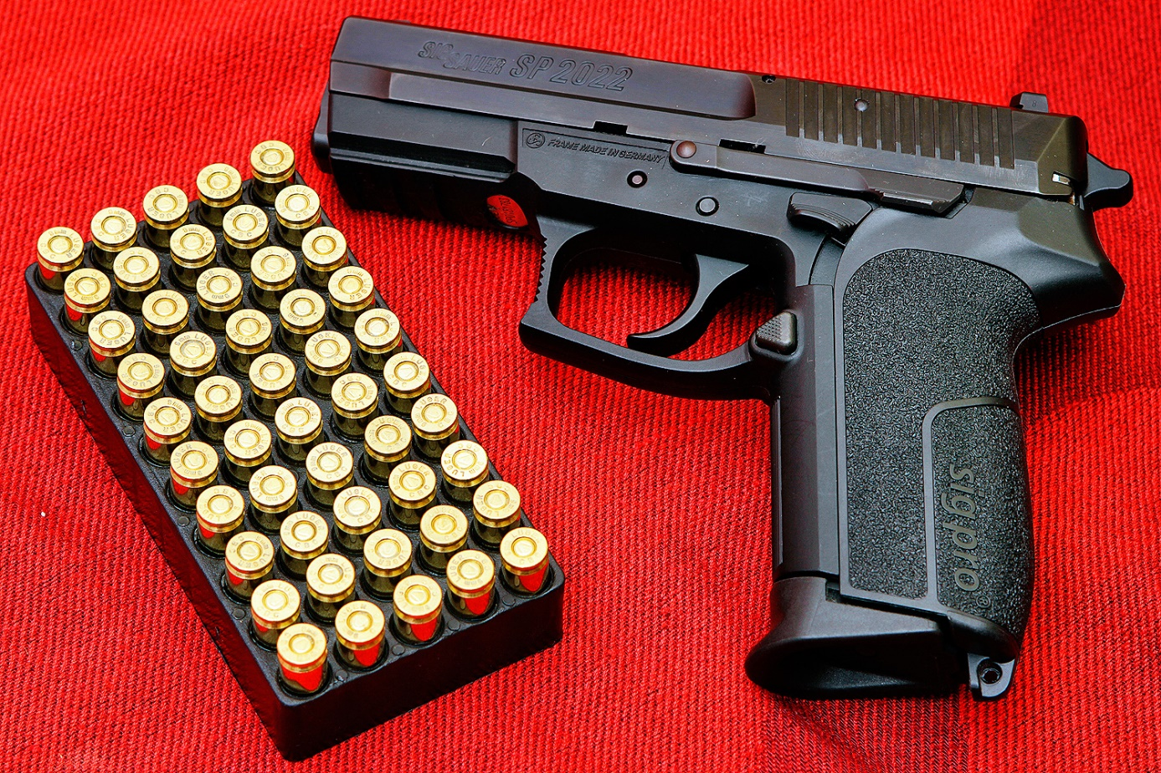

Join us !